Abstract—These instructions give you guidelines for preparing papers for 8th Iberian Meeting on Computational Electromagnetics. The electronic file of your paper will be formatted further by organizers. Define all symbols used in the abstract. Do not cite references in the abstract. Do not delete the blank line immediately above the abstract; it sets the footnote at the bottom of this column.
Preparation of Manuscripts for 8th Iberian Meeting on Computational Electromagnetics (VIII EIEC)
First A. Author, Second B. Author, Jr., and Third C. Author, Member, IEEE

Index Terms—About four key words or phrases in alphabetical order, separated by commas.

INTRODUCTION
THIS document is a template for Microsoft Word versions 6.0 or later. When you open VIII_EIEC_template.doc, select “Page Layout” from the “View” menu in the menu bar (View | Page Layout), which allows you to see the footnotes. Then, type over sections of VIII_EIEC_template.doc or cut and paste from another document and use markup styles. The pull-down style menu is at the left of the Formatting Toolbar at the top of your Word window (for example, the style at this point in the document is “Text”). Highlight a section that you want to designate with a certain style, and then select the appropriate name on the style menu. The style will adjust your fonts and line spacing. Do not change the font sizes or line spacing to squeeze more text into a limited number of pages. Use italics for emphasis; do not underline.
To insert images in Word, position the cursor at the insertion point and either use Insert | Picture | From File or copy the image to the Windows clipboard and then Edit | Paste Special | Picture (with “float over text” unchecked).
The organizers will do the final formatting of your paper.

Procedure for Paper Submission

Review Stage
After receiving the acceptance letter, you have 60 days (until September 30, 2011) to prepare the final manuscript to be published in the meeting proceedings. Please, send the doc file together with a pdf version of the document to the following email address: antonio.topa@lx.it.pt. The maximum size of the paper is 4 (four) pages.

Final Stage
When you submit your final version, the paper will be processed by members of the organization in order to introduce the necessary modifications to be inserted in the final document to be published. Please, designate a single author as “corresponding author” and be sure of providing all the necessary information for further contacts in the future.

Figures
Format and save your graphic images using a suitable graphics processing program that will allow you to create the images as PostScript (PS), Encapsulated PostScript (EPS), or Tagged Image File Format (TIFF), sizes them, and adjusts the resolution settings.
If you are importing your graphics into this Word template, please use the following steps:
Under the option EDIT select PASTE SPECIAL. A dialog box will open, select paste picture, then click OK. Your figure should now be in the Word Document.
If you are preparing images in TIFF, EPS, or PS format, note the following. High-contrast line figures and tables should be prepared with 600 dpi resolution and saved with no compression, 1 bit per pixel (monochrome), with file names in the form of “fig3.tif” or “table1.tif.”
Photographs and grayscale figures should be prepared with 300 dpi resolution and saved with no compression, 8 bits per pixel (grayscale).
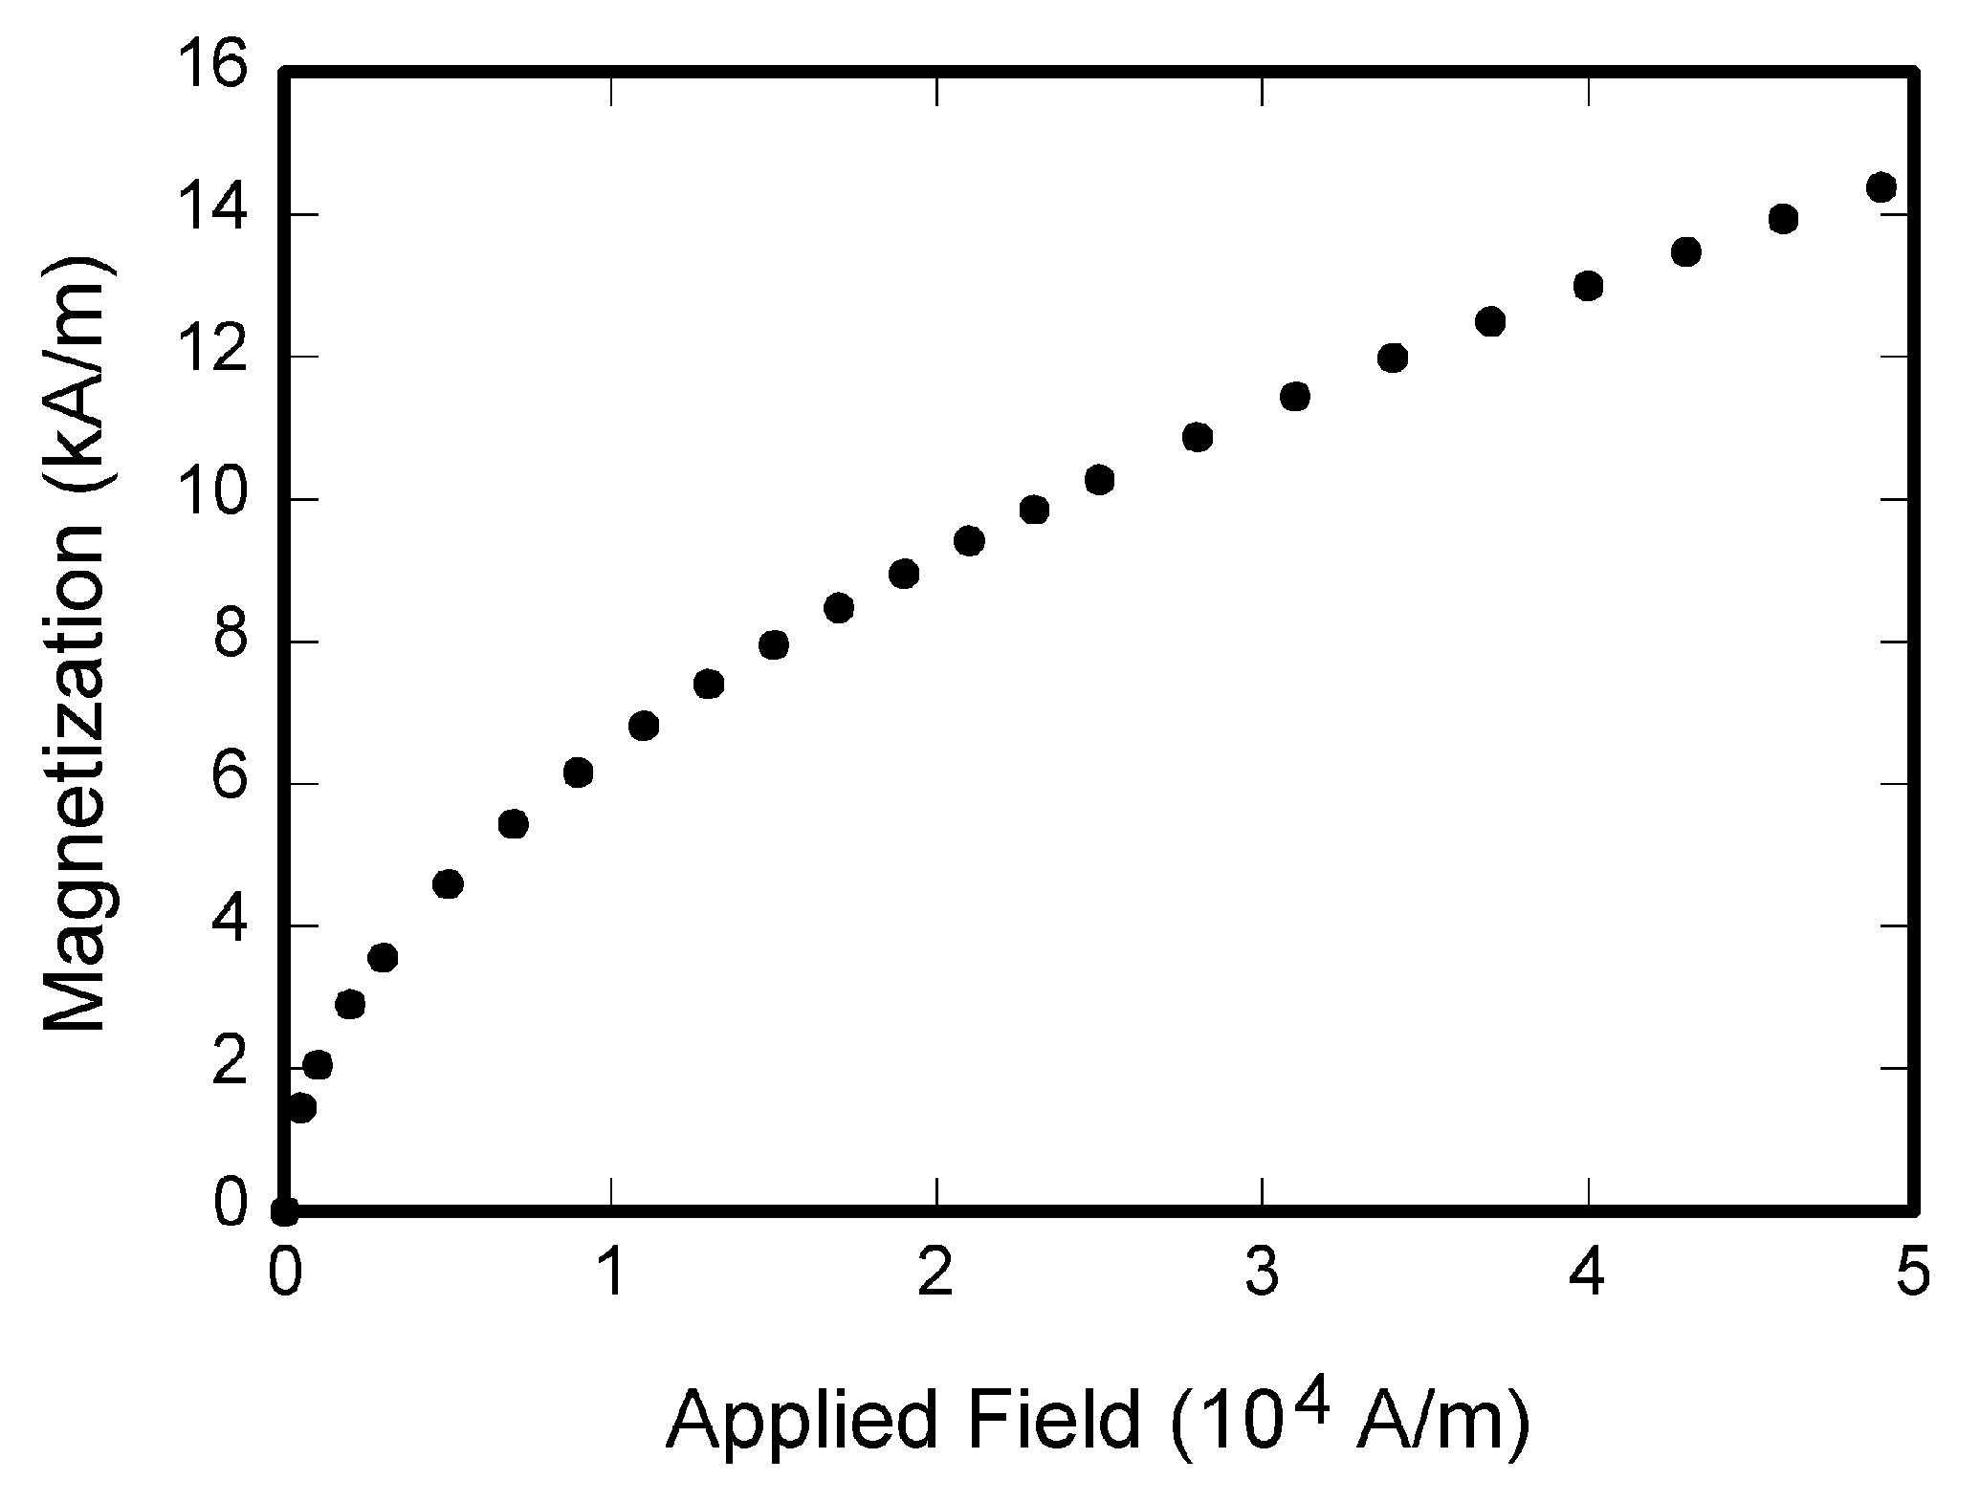
Fig. 1. Magnetization as a function of applied field. Note that “Fig.” is abbreviated. There is a period after the figure number, followed by two spaces. It is good practice to explain the significance of the figure in the caption.

Sizing of Graphics
Most charts graphs and tables are one column wide (3 1/2 inches or 21 picas) or two-column width (7 1/16 inches, 43 picas wide). We recommend that you avoid sizing figures less than one column wide, as extreme enlargements may distort your images and result in poor reproduction. Therefore, it is better if the image is slightly larger, as a minor reduction in size should not have an adverse affect the quality of the image.

MATH
If you are using Word, use either the Microsoft Equation Editor or the MathType add-on (http://www.mathtype.com) for equations in your paper (Insert | Object | Create New | Microsoft Equation or MathType Equation). “Float over text” should not be selected.

Units
Use SI (MKS) as primary units. English units may be used as secondary units (in parentheses). An exception is when English units are used as identifiers in trade, such as “3½-in disk drive.”
The SI unit for magnetic field strength H is A/m. However, if you wish to use units of T, either refer to magnetic flux density B or magnetic field strength symbolized as µ₀H. Use the center dot to separate compound units, e.g., “A·m².”

Helpful Hints

Figures and Tables
Please, place your figures and tables in the place you intend they appear in the final published document. Large figures and tables may span both columns. Place figure captions below the figures; place table titles above the tables. If your figure has two parts, include the labels “(a)” and “(b)” as part of the artwork. Please verify that the figures and tables you mention in the text actually exist. Please do not include captions as part of the figures. Do not put captions in “text boxes” linked to the figures. Do not put borders around the outside of your figures. Use the abbreviation “Fig.” even at the beginning of a sentence. Do not abbreviate “Table.” Tables are numbered with Roman numerals.
Figure axis labels are often a source of confusion. Use words rather than symbols. As an example, write the quantity “Magnetization,” or “Magnetization M,” not just “M.” Put units in parentheses. Do not label axes only with units. As in Fig. 1, for example, write “Magnetization (A/m)” or “Magnetization (Am⁻¹),” not just “A/m.” Do not label axes with a ratio of quantities and units. For example, write “Temperature (K),” not “Temperature/K.”
Multipliers can be especially confusing. Write “Magnetization (kA/m)” or “Magnetization (10³ A/m).” Do not write “Magnetization (A/m) × 1000” because the reader would not know whether the top axis label in Fig. 1 meant 16000 A/m or 0.016 A/m. Figure labels should be legible, approximately 8 to 12 point type.

References
Number citations consecutively in square brackets [1]. The sentence punctuation follows the brackets [2]. Multiple references [2], [3] are each numbered with separate brackets [1]–[3]. When citing a section in a book, please give the relevant page numbers [2]. In sentences, refer simply to the reference number, as in [3]. Do not use “Ref. [3]” or “reference [3]” except at the beginning of a sentence: “Reference [3] shows ... .” Please do not use automatic endnotes in Word, rather, type the reference list at the end of the paper using the “References” style.
Number footnotes separately in superscripts (Insert | Footnote). Place the actual footnote at the bottom of the column in which it is cited; do not put footnotes in the reference list (endnotes). Use letters for table footnotes (see Table I).
Please note that the references at the end of this document are in the preferred referencing style. Give all authors’ names; do not use “et al.” unless there are six authors or more. Use a space after authors’ initials. Papers that have not been published should be cited as “unpublished” [4]. Papers that have been accepted for publication, but not yet specified for an issue should be cited as “to be published” [5]. Papers that have been submitted for publication should be cited as “submitted for publication” [6]. Please give affiliations and addresses for private communications [7].
Capitalize only the first word in a paper title, except for proper nouns and element symbols. For papers published in translation journals, please give the English citation first, followed by the original foreign-language citation [8].

Abbreviations and Acronyms
Define abbreviations and acronyms the first time they are used in the text, even after they have already been defined in the abstract. Abbreviations such as IEEE, SI, ac, and dc do not have to be defined. Abbreviations that incorporate periods should not have spaces: write “C.N.R.S.,” not “C. N. R. S.”

Equations
Number equations consecutively with equation numbers in parentheses flush with the right margin, as in (1). First use the equation editor to create the equation. Then select the “Equation” markup style. Press the tab key and write the equation number in parentheses. To make your equations more compact, you may use the solidus ( / ), the exp function, or appropriate exponents. Use parentheses to avoid ambiguities in denominators. Punctuate equations when they are part of a sentence, as in

$\begin{aligned}\int{ F(r,ϕ)} \text{dr} dϕ=[{σr}_{2} (2μ_{0})] \\ ⋅ \int{ \text{exp}}(−λ|z_{j}−z_{i}| ) λ^{−1} J_{1}(λ r_{2}) J_{0}(λ r_{i}) dλ \text{.}\end{aligned}$ (1)

Be sure that the symbols in your equation have been defined before the equation appears or immediately following. Italicize symbols (T might refer to temperature, but T is the unit tesla). Refer to “(1),” not “Eq. (1)” or “equation (1),” except at the beginning of a sentence: “Equation (1) is ... .”

Other Recommendations
Use one space after periods and colons. Hyphenate complex modifiers: “zero-field-cooled magnetization.” Avoid dangling participles, such as, “Using (1), the potential was calculated.” [It is not clear who or what used (1).] Write instead, “The potential was calculated by using (1),” or “Using (1), we calculated the potential.”
Use a zero before decimal points: “0.25,” not “.25.” Use “cm³,” not “cc.” Indicate sample dimensions as “0.1 cm × 0.2 cm,” not “0.1 × 0.2 cm².” The abbreviation for “seconds” is “s,” not “sec.” Do not mix complete spellings and abbreviations of units: use “Wb/m²” or “webers per square meter,” not “webers/m².” When expressing a range of values, write “7 to 9” or “7-9,” not “7~9.”
A parenthetical statement at the end of a sentence is punctuated outside of the closing parenthesis (like this). (A parenthetical sentence is punctuated within the parentheses.) In American English, periods and commas are within quotation marks, like “this period.” Other punctuation is “outside”! Avoid contractions; for example, write “do not” instead of “don’t.” The serial comma is preferred: “A, B, and C” instead of “A, B and C.”
If you wish, you may write in the first person singular or plural and use the active voice (“I observed that ...” or “We observed that ...” instead of “It was observed that ...”). Remember to check spelling.
An excellent style manual and source of information for science writers is [9]. A general IEEE style guide and an Information for Authors are both available at http://www.ieee.org/web/publications/authors/transjnl/index.html

Conclusion
A conclusion section is required. Although a conclusion may review the main points of the paper, do not replicate the abstract as the conclusion. A conclusion might elaborate on the importance of the work or suggest applications and extensions.
Appendix
Appendixes, if needed, appear before the acknowledgment.
Acknowledgment
The preferred spelling of the word “acknowledgment” in American English is without an “e” after the “g.”, but this is not our problem and you can also use “acknowledgement”. Use the singular heading even if you have many acknowledgments. Avoid expressions such as “One of us (S.B.A.) would like to thank ... .” Instead, write “F. A. Author thanks ... .” Sponsor and financial support acknowledgments are placed in the unnumbered footnote on the first page, not here.
References
- G. O. Young, “Synthetic structure of industrial plastics (Book style with paper title and editor),” in Plastics, 2nd ed. vol. 3, J. Peters, Ed. New York: McGraw-Hill, 1964, pp. 15–64.
- W.-K. Chen, Linear Networks and Systems (Book style). Belmont, CA: Wadsworth, 1993, pp. 123–135.
- H. Poor, An Introduction to Signal Detection and Estimation. New York: Springer-Verlag, 1985, ch. 4.
- B. Smith, “An approach to graphs of linear forms (Unpublished work style),” unpublished.
- E. H. Miller, “A note on reflector arrays (Periodical style—Accepted for publication),” IEEE Trans. Antennas Propagat., to be published.
- J. Wang, “Fundamentals of erbium-doped fiber amplifiers arrays (Periodical style—Submitted for publication),” IEEE J. Quantum Electron., submitted for publication.
- C. J. Kaufman, Rocky Mountain Research Lab., Boulder, CO, private communication, May 1995.
- Y. Yorozu, M. Hirano, K. Oka, and Y. Tagawa, “Electron spectroscopy studies on magneto-optical media and plastic substrate interfaces (Translation Journals style),” IEEE Transl. J. Magn.Jpn., vol. 2, Aug. 1987, pp. 740–741 [Dig. 9th Annu. Conf. Magnetics Japan, 1982, p. 301].
- M. Young, The Techincal Writers Handbook. Mill Valley, CA: University Science, 1989.
- J. U. Duncombe, “Infrared navigation—Part I: An assessment of feasibility (Periodical style),” IEEE Trans. Electron Devices, vol. ED-11, pp. 34–39, Jan. 1959.
- S. Chen, B. Mulgrew, and P. M. Grant, “A clustering technique for digital communications channel equalization using radial basis function networks,” IEEE Trans. Neural Networks, vol. 4, pp. 570–578, Jul. 1993.
- R. W. Lucky, “Automatic equalization for digital communication,” Bell Syst. Tech. J., vol. 44, no. 4, pp. 547–588, Apr. 1965.
- S. P. Bingulac, “On the compatibility of adaptive controllers (Published Conference Proceedings style),” in Proc. 4th Annu. Allerton Conf. Circuits and Systems Theory, New York, 1994, pp. 8–16.
- G. R. Faulhaber, “Design of service systems with priority reservation,” in Conf. Rec. 1995 IEEE Int. Conf. Communications, pp. 3–8.
- W. D. Doyle, “Magnetization reversal in films with biaxial anisotropy,” in 1987 Proc. INTERMAG Conf., pp. 2.2-1–2.2-6.
- G. W. Juette and L. E. Zeffanella, “Radio noise currents n short sections on bundle conductors (Presented Conference Paper style),” presented at the IEEE Summer power Meeting, Dallas, TX, Jun. 22–27, 1990, Paper 90 SM 690-0 PWRS.
- J. G. Kreifeldt, “An analysis of surface-detected EMG as an amplitude-modulated noise,” presented at the 1989 Int. Conf. Medicine and Biological Engineering, Chicago, IL.
- J. Williams, “Narrow-band analyzer (Thesis or Dissertation style),” Ph.D. dissertation, Dept. Elect. Eng., Harvard Univ., Cambridge, MA, 1993.
- N. Kawasaki, “Parametric study of thermal and chemical nonequilibrium nozzle flow,” M.S. thesis, Dept. Electron. Eng., Osaka Univ., Osaka, Japan, 1993.
- J. P. Wilkinson, “Nonlinear resonant circuit devices (Patent style),” U.S. Patent 3 624 12, July 16, 1990.
- IEEE Criteria for Class IE Electric Systems (Standards style), IEEE Standard 308, 1969.
- Letter Symbols for Quantities, ANSI Standard Y10.5-1968.
- R. E. Haskell and C. T. Case, “Transient signal propagation in lossless isotropic plasmas (Report style),” USAF Cambridge Res. Lab., Cambridge, MA Rep. ARCRL-66-234 (II), 1994, vol. 2.
- E. E. Reber, R. L. Michell, and C. J. Carter, “Oxygen absorption in the Earth’s atmosphere,” Aerospace Corp., Los Angeles, CA, Tech. Rep. TR-0200 (420-46)-3, Nov. 1988.
- (Handbook style) Transmission Systems for Communications, 3rd ed., Western Electric Co., Winston-Salem, NC, 1985, pp. 44–60.
- Motorola Semiconductor Data Manual, Motorola Semiconductor Products Inc., Phoenix, AZ, 1989.
- (Basic Book/Monograph Online Sources) J. K. Author. (year, month, day). Title (edition) [Type of medium]. Volume (issue). Available: http://www.(URL)
- J. Jones. (1991, May 10). Networks (2nd ed.) [Online]. Available: http://www.atm.com
- (Journal Online Sources style) K. Author. (year, month). Title. Journal [Type of medium]. Volume(issue), paging if given. Available: http://www.(URL)
- R. J. Vidmar. (1992, August). On the use of atmospheric plasmas as electromagnetic reflectors. IEEE Trans. Plasma Sci. [Online]. 21(3). pp. 876–880. Available: http://www.halcyon.com/pub/journals/21ps03-vidmar

 Manuscript received October 9, 2001. (Write the date on which you submitted your paper for review.) This work was supported in part by the U.S. Department of Commerce under Grant BS123456 (sponsor and financial support acknowledgment goes here). Paper titles should be written in uppercase and lowercase letters, not all uppercase. Avoid writing long formulas with subscripts in the title; short formulas that identify the elements are fine (e.g., "Nd–Fe–B"). Do not write “(Invited)” in the title. Full names of authors are preferred in the author field, but are not required. Put a space between authors’ initials. F. A. Author is with the National Institute of Standards and Technology, Boulder, CO 80305 USA (corresponding author to provide phone: 303-555-5555; fax: 303-555-5555; e-mail: author@ boulder.nist.gov). S. B. Author, Jr., was with Rice University, Houston, TX 77005 USA. He is now with the Department of Physics, Colorado State University, Fort Collins, CO 80523 USA (e-mail: author@lamar.colostate.edu). T. C. Author is with the Electrical Engineering Department, University of Colorado, Boulder, CO 80309 USA, on leave from the National Research Institute for Metals, Tsukuba, Japan (e-mail: author@nrim.go.jp).
It is recommended that footnotes be avoided (except for the unnumbered footnote with the receipt date on the first page). Instead, try to integrate the footnote information into the text.

