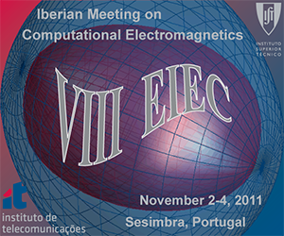

VIII ENCONTRO DE ELECTROMAGNETISMO COMPUTACIONAL

8th IBERIAN MEETING ON COMPUTATIONAL ELECTROMAGNETICS

Lisbon, November 2–4, 2011

Venue: Hotel do Mar, Sesimbra

VIII EIEC Registration form

The 8th Iberian Meeting on Computational Electromagnetics (VIII Encontro Ibérico de Electromagnetismo Computacional) will be held in Sesimbra (Lisboa), from 2 to 4 November, 2011.

Registration Deadline: September 30, 2011

Family name: First Name
Institution:
Street Address:
City & Post Code: Country: …………………………
Phone: Email:
NIF/CIF/VAT (indispensable for receipt emission)
Receipt name

Registration fee: 250 euros

The registration fee should be paid by bank transfer to the following bank account:

Holder: Instituto de Telecomunicações
Bank: BPI–Banco Português de Investimento
IBAN: PT50 0010 0000 2247 8140 00185
SWIFT/BIC: BBPIPTPL
Description: Add your “Last name/Name–VIII EIEC”

After filling this form, send it by mail to Sara Correia (sara.correia@lx.it.pt).

PLEASE, ATTACH A COPY OF THE TRANSFER SUPPORTING DOCUMENT.

Registration fee includes all conference materials, Wi-Fi, dinner on November 1 and 2, the conference banquet on Thursday, November 3, and an all day tour on Friday, November 4 (with lunch included).

